

**GROUP 1: GIT AND GITHUB**

**MODULE CODE AND TITLE**: ITLDO801- DEVELOPMENT OPERATIONS

**LECTURE NAME:** Mr. BONAVENTURE UWAMAHORO

**RQF LEVEL: 8**

**PROGRAM: INFORMATION TECHNOLOGY**

**Group names & Regno:** 1. Vincent SHYAKA 24RP03809

2. Steven BANANIYE 24RP04326

3. Claudine MUSHIMIYIMANA 23RP00498

4. Jean Baptiste NDUWAYEZU 23RP00470

5. Patrice TUYIZERE 23RP00987

6. Anitha MUTESI 24RP14272

**1. Git: A Version Control System**

Git is an open-source distributed version control system created by Linus Torvalds in 2005. It is designed to handle everything from small to very large projects with speed and efficiency.

Git helps developers track changes in their codebase, collaborate with others, and manage versions of their project files.

**Importance of using Git**

**Collaboration:** Enables multiple developers to work simultaneously.

**History:** Provides a detailed history of project changes.

**Branching:** Supports branching and merging for feature development

**Key Features of Git:**

* **Version Tracking:** Git tracks changes made to files over time, allowing users to revert to previous versions if needed.
* **Branching and Merging:** Developers can create branches to work on specific features or fixes independently and later merge them into the main branch.
* **Distributed Nature:** Each developer has a full copy of the repository, enabling offline access and ensuring redundancy.
* **Speed and Efficiency:** Git performs operations like commits, diffs, and merges locally, making it faster than centralized systems.

**Basic Git Commands:**

* git init: Initializes a new Git repository.
* git add: Stages changes to be committed.
* git commit: Saves staged changes to the repository with a message.
* git push: Uploads local repository changes to a remote repository.
* git pull: Fetches and integrates changes from a remote repository.
* git clone: Copies a remote repository to your local machine.

1. **Setting Up Git**

* **Installation:** Download and install Git based on your operating system (Windows, macOS, or Linux).
* **Configuration**

git config --global user.name "Your Name"

git config --global user.email [your_email@example.com](mailto:your_email@example.com)

1. **Verify Configuration:** git config --list
2. **Initializing a Repository**

Use **git init** to start tracking a project in the current directory, turning it into a Git repository.

**Example:** cd my-project, git init

1. **Managing Changes**

* Check Status**:** Use **git status** to see which files have changed.
* Staging Changes**:** Add specific files to the staging area with **git add [file]** or all changes with **git add.**
* Committing Changes**:** Record changes in the repository with: **git commit -m "Descriptive message"**

1. **Remote Repositories**

* Cloning: Copy a remote repository to your local system with: **git clone [repository URL]**
* Pushing Changes**:** Upload local commits to the remote repository: **git push origin main**
* Pulling Changes**:** Synchronize your local repository with updates from the remote: **git pull**

1. **Branching and Merging**

* Branching: Create separate branches for new features or changes:

Create a Branch: **git branch feature-branch**

Switch to a Branch: **git checkout feature-branch**

Combine these steps**: git checkout -b feature-branch**

* **Merging:** Integrate changes from one branch into another:

**git checkout main**

**git merge feature-branch**

* **Deleting a branch**

git branch -d <branch_name>

1. **Stashing Changes**

Temporarily save unfinished work with: **git stash**

apply the stashed changes: **git stash apply**

1. **Advanced Features**

**Tags:** Use tags to mark specific points in history, such as a version release:

git tag -a v1.0 -m "Release version 1.0"

git push origin v1.0

* **SSH Setup:** Generate and add SSH keys for secure access to GitHub repositories.

ssh-keygen -t ed25519 -C [your_email@example.com](mailto:your_email@example.com)

* Start the ssh-agent in the background.

eval "$(ssh-agent -s)"

* Add your SSH private key to the ssh-agent.

ssh-add ~/.ssh/id_ed25519

**Adding a new SSH key to your GitHub account**

Copy the SSH public key to your clipboard.

cat ~/.ssh/id_ed25519.pub

**2. GitHub: A Platform for Collaboration**

GitHub is a web-based hosting service for Git repositories. It provides a graphical interface, collaboration tools, and additional features like issue tracking, project management, and code review. GitHub makes it easier for developers to share their work, collaborate with others, and manage projects.

**Key Features of GitHub:**

* **Remote Hosting:** GitHub acts as a remote repository, enabling developers to share code and collaborate.
* **Collaboration Tools:** Users can work together on repositories, track issues, and discuss changes using pull requests.
* **Version Control Visualization:** GitHub provides an intuitive interface to visualize commits, branches, and changes.
* **Integration with Tools:** GitHub integrates with CI/CD pipelines, testing frameworks, and third-party services.
* **Open Source Projects:** Many open-source projects are hosted on GitHub, making it a hub for learning and contribution.

**Advantages of GitHub**

**1. Version Control:** Tracks changes in code, allowing developers to manage and revert to earlier versions easily.

**2. Collaboration and Teamwork:** Facilitates collaboration among multiple developers using features like branches, pull requests, and code reviews.

**3. Open Source Contributions:** Provides a platform for sharing and contributing to open-source projects, fostering innovation and learning.

**4. Integration with Tools:** Seamlessly integrates with CI/CD pipelines, project management tools, and third-party applications like Jenkins, Jira, and Slack.

**5. Accessibility and Hosting:** Provides a centralized location for remote repository hosting, accessible from anywhere with an internet connection.

**6. Documentation Support:** Supports README files, wikis, and other forms of documentation, improving project clarity and usability.

**7. Portfolio Building:** Acts as an online portfolio for developers, showcasing skills and projects to potential employers or collaborators.

**Disadvantages of GitHub**

**1. Cost for Private Repositories:** While public repositories are free, some advanced features and private repositories require paid plans for organizations.

**2. Internet Dependency:** Requires an active internet connection for most interactions, limiting usability in offline scenarios.

**3. Limited Large File Support:** GitHub is not optimized for handling large files or repositories, and additional tools like Git LFS may be required.

**The difference between Git and GitHub**

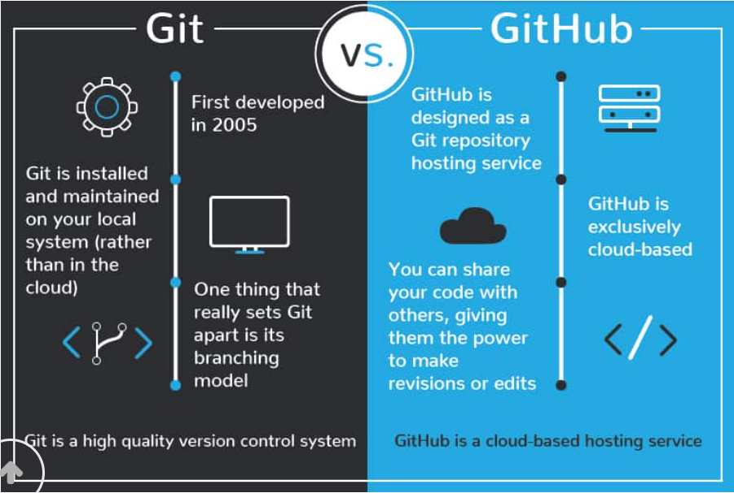

|  |  |  |
| --- | --- | --- |
| **Feature** | **Git** | **GitHub** |
| **Type** | Version control system (software/tool). | Cloud-based platform/service for hosting Git repositories. |
| **Purpose** | Tracks changes in files, manages versions, and facilitates collaboration. | Allows sharing, collaboration, and remote management of Git repositories. |
| **Functionality** | Works locally on your computer. | Works online to host repositories and provide collaboration tools. |
| **Internet Requirement** | Can work offline. | Requires an internet connection for accessing and managing repositories. |
| **Key Features** | Version control, branching, merging, and tracking file history. | Hosting Git repositories, pull requests, issue tracking, and team collaboration tools. |
| **Usage** | Operated through the command line or tools like Git GUI. | Accessible via a web interface, desktop app, or integration with IDEs. |
| **Scope** | Focuses on version control. | Focuses on repository hosting, team collaboration, and project management. |
| **Examples** | git init, git add, git commit, git merge, etc. | Create repositories, manage pull requests, review code, and collaborate on projects. |
| **Ownership** | Free and open-source software maintained by the Git community. | Owned by Microsoft (acquired in 2018). |